Page 1
Here Popper argues that philosophy, like science (or any discipline for that matter) is not distinguished so much by its subject matter as by the problems that are investigated. The question "What is philosophy?" says Popper is rather a pointless one as it leads the questioner down a road of essentialist answers and we are bound to end up in arguments about whether some bit of subject matter "really" is philosophical rather than scientific

Page 2
Here Popper explains that the reason we separate subjects is largely due to historical reasons and matters of "administrative convenience". The populariser Sam Harris follows Popper on this exact point in fact and has made this point repeatedly (for example where he writes "The boundaries between true intellectual disciplines are currently enforced by little more than university budgets and architecture. Is the Shroud of Turin a medieval forgery? This is a question of history, of course, and of archaeology, but the techniques of radiocarbon dating make it a question of chemistry and physics as well." (from https://www.samharris.org/blog/item/our-narrow-definition-of-science)) Popper explains that the question of "What is philosophy?" like the question of "What is Science?" or "What is geology?" is always open to revision because the subjects always tend towards unification and we should be "students of problems" (rather than subjects) and problems tend to cut across disciplines. Popper uses the example of geology: the problem of finding uranium is going to include physics and chemistry and lots of things. Popper then says that although this view of problems cutting across disciplines is true, nonetheless problems can still be seen as arising out of one subject or other. On this page Popper brings up the central question "Are there philosophical problems?". This is the question that separated him from Wittgenstein. The paper before us now moves into Popper's case that the answer to the question is a definitive "yes!"

Page 3
So are there philosophical problems? Popper explains part of Wittgenstein's view. In Wittgenstien’s view the answer is: no. It’s “no” because all actual problems reduce to scientific ones in the final analysis. Philosophical problems, in this view, are pseudo-problems - a result of misunderstandings in language rather than anything truly substantive. So philosophy is not a place where you form theories as such (explanations of reality: moral, political, epistemological, meta-scientific and so on) but rather it is an activity where we simply "unmask philosophical nonsense". (Popper would agree that "unmasking philosophical nonsense is an important part of philosophy. But not all of it is reducible to this.)

Page 4
Popper flags for us that he is about to explain, defend and then criticise Wittgenstein’s position. This is completely in line with his philosophy of philosophy: the arguments of your opponents should always be put in their strongest possible terms: at least as well as your opponents would, if not even better than they would. But whatever the case, not in a way you expect they would obviously object to ( again this is what some others have recently begun calling “steel-manning” (to be contrasted with “straw-maning”). There seems to be a strong form of steel-manning which is something like: making the case of your opponent even stronger than what they intended (this doesn’t seem to be advisable because that might not be what your opponent intended) or the weaker form of Steel-manning which is simply something like what Popper attempted: to as fairly and clearly represent the position of one’s opponent in terms they would not object to.

Popper says a philosopher should do philosophy - which is to say philosophize and not just talk about philosophy (or the work of other philosophers). This, of course, is exactly what I am doing but in my defense I am not purporting to do philosophy here and now, I am attempting to be a philosophy communicator if anything. Whatever the case, Popper says if he thought Wittgenstein were correct, then he Popper, would give up philosophy. Talking about philosophy is clearly not for him. He wants to solve problems in philosophy: that’s what drives him. Not waxing lyrical on the work of others. But he says the reason, of course, he does talk about philosophy is, eventually, to get to philosophizing which is to say: solving some problems. I like to think this is largely my motivation here on my website and in my podcast. Given I spend the better part of my contributions to the critical rationalist community engaging with the ideas of people I am opposed to: academic pessimists and prophets, justificationists and pseudo-scientists and so on, I hope I do this in some measure to address some philosophical problem that underpins their misconceptions and so, like Popper, if only modestly, to make some headway towards clarity on that topic. But I readily admit, I spend rather more time on all the ways certain ideas are false rather than making headway on what is actually true. Popper on this page speaks about the (relatively recent) historical gulf between science and philosophy and that this led to (the philosopher and mathematician) Bertrand Russell influencing Wittgenstein via his classification of expressions in a language into 3 kinds: true, false and meaningless. So here we have Popper tracing Wittgenstein to Russell. We cannot blame Russell for Wittgenstein however, in the same way we cannot really blame Wittgenstein for schools of Grievance Studies today (he’d likely be horrified by them) – but it is informative to see the philosophical roots of these ideas and thus excavate the underlying error or the root of the error. For it is somewhat like geology in that respect. How was that metamorphic rock generated? It was only possible given, for example, the deep compression, stress and warping of other kinds of rocks like sedimentary or igneous. A metamorphic rock is altogether a different substance than the igneous rock that was its chemical precursor. But its origins are still there, imprinted as it were, within its deep structure. So it can be with ideas.

Page 5
Here Popper explains that part of the motivation for this was to distinguish between false and meaningless statements as resolutions to logical paradoxes. (The former – a false statement - might be something like “3 times 4 is 173” but the latter – a meaningless statement - is “3 times 4 are cows”). Popper says Wittgenstein followed Russell down this road and concluded that, therefore, all philosophy consists of meaningless statements. And this meant there could not possibly be philosophical problems. *Alleged* problems in philosophy he categorised into 4 kinds: (1) actually logical/mathematical problems (2) actually scientific (3)combinations of 1 and 2 (4) meaningless statements of the kind Russell said.

Here (1) and (2) ultimately could be answered by the methods of mathematics and science. Popper says that Wittgenstein’s proposal here was an ingenious attempt to eradicate philosophy and theology and it led to the creation of an entirely new school of “philosophy” (language analysis).

Not also that Popper here concedes that “Wittgenstein’s idea of eradicating philosophy (and theology) with the help of an adaption of Russell’s theory of types was ingenious and original (and more radical even than Comte’s positivism which it resembles closely.”). So Popper generously gives Wittgenstein his due. He is not berating his intelligence. The opposite: he is praising his genius. He just thinks he’s completely wrong. As geniuses can be – or even almost always are. Like the rest of us.

Page 6
For the first time Popper introduces the “problem” vs “puzzle” dichotomy. Remember Popper believes in genuine problems in philosophy: open, deep questions about reality whose solutions must be drawn from philosophical theories (whose purpose is to solve problems - just as scientific theories solve scientific problems). But this new school of “language analysis” that Wittgenstein founded said that all such problems were apparent only. In fact they were language *puzzles* and if you figured out where the language went wrong, the puzzle would be solved and the apparent problem would vanish.

Popper says he fails to understand why language analysts would even want to do that job if that is what philosophy amounted to. It seems like it’s pointless. Why do philosophy if it’s not about deep problem solving and, instead is about puzzle solving (i.e: like spending your work day doing cross words or something)? Popper fully admits here that he understands some of the motivation - after all many people speak nonsense and write nonsense - especially dangerous nonsense (here he alludes to philosophy that leads to terrible political ideas like communism or fascism and of course today we would speak about postmodernism and “critical theory” and other kinds of “WOKE” activism).

But then again, also: some of that - even when, say, it’s nonsense only because it’s poorly worded might contain some truth worth listening to. In other words: not all nonsense is meaningless. It’s as if Popper is claiming of some people who do not speak or write carefully, “What you’ve said there is, strictly, nonsense given your poor grammar, however: I understand what you are trying to get at. And your central point is understandable (and perhaps even true).”

Popper also uses the example here of calculus in mathematics which, when it was first discovered probably seemed to every other mathematician “nonsense”. (Calculus is the mathematics of continuous change. Until Newton and Leibnitz invented it, mathematics was largely about geometry and counting/algebra. But calculus introduces the idea of limits and infinities of various kinds (and “infinitesimals”) in order to understand the concept of continuous change. The point here might also be: something that might seem to be nonsense to you or in some sense a contradiction to you, might nonetheless contain truth and be used to solve problems. (As of course, calculus can. One might be tempted to say that there is almost no area of physical science left untouched by calculus). Popper says here that it’s understandable that people looked at the high precision language of mathematics and compared it to the “vagueness” of philosophical language and this was impressive to the followers of Wittgenstein. But Popper observes: had there been a Wittgenstein at the time when calculus was first created: he possibly might have attempted to eradicate the whole calculus project because of its similar vagueness (as it was understood only vaguely, like all new discoveries are, when they are first discovered). The most famous statement ever uttered by Wittgenstein comes next: “Whereof one cannot speak, thereof one must be silent” (I’ve always thought it was “…one must remain silent”. Popper quotes Schroedinger’s reply “But it is only here that speaking becomes interesting”. [Wittgenstein’s original quote there has been interpreted in many ways. (1) in the strong sense it can be used to dismiss all of metaphysics and theology (2) (and this is probably the way Wittgenstein intended, in a weaker sense) it can be used to admit that there exist phenomena - metaphysical or spiritual - for which no words are adequate and can only possibly mislead and (therefore) we should partition off statements about the world - our use of language - to be about things that are “empirically” true or false.

Page 7
Popper agrees we should all strive for clarity, but that language analysis could be used as a technique whereby scientific texts could be shown to be filled with “meaningless pseudo-propositions” and tautologies.

Now Popper begins to defend Wittgenstein. He begins with an admission that much of philosophy is “meaningless verbiage” and that Wittgenstein did something to correct this - although Popper thinks Russell probably deserves as much or more credit for this because he had such a lucid style. Popper says that Wittgenstein is correct that some schools of philosophy degenerate in such a way that its problems can become practically indistinguishable from the pseudo-problems Wittgenstein says they actually are. Popper argues this is a consequence of “philosophical inbreeding” where the philosophers search for issues within the subject of philosophy to the exclusion of those arising from outside - philosophical problems in mathematics, politics, religion or science, for example. Popper presents his first thesis:

“Genuine philosophical problems are always rooted in urgent problems outside philosophy, and they die if the roots decay.”

Popper says philosophers get sidetracked when they think there is some method to philosophy that is like some recipe which produces truth if only you follow it carefully.

Page 8
But methods do not matter to Popper in philosophy. What matters is careful attention paid to, and passion for problems. Popper distinguishes two kinds of “thinkers” - those who like problems (people who feel that the problem is so real it is like a disorder they have to get out of their system: it is very consuming) and on the other hand those who just apply some technique already known - which is to say “puzzle solvers”. Here he is agreeing with Wittgenstein that such “puzzles” indeed exist and there are people who pursue them even in philosophy but he disagrees with Wittgenstein that all problems (in philosophy) are ultimately puzzles (in language).

Next Popper makes the point that philosophy education is idiosyncratic. In that subject we give learners the works of the great philosophers: The Greeks, the Europeans, the big names between Plato and Descartes and Mill. The student reads these and then discusses the readings abstractly. And more perversely might attempt to reconstruct the way those dead philosophers wrote (usually circuitously and confusingly because they were not to sure of how to write properly themselves). David Deutsch makes this point as well: that philosophy, unlike physics or any area of science (to which it is more closely related than, say, English Literature because science is a problem solving process while Literature is an appreciation “process”) - philosophy is obscure in that we read the original texts. But no physics student would ever learn relativity from Einstein’s initial writings on the topic. They’d pick up a modern text. Why shouldn’t a philosophy student do that and solve philosophical problems like a physics student solves physics problems? (In truth much of physics learning is also, sadly, “puzzles” of the kind Wittgenstein complained about: a known method applied to a situation where the result is known beforehand.)

Page 9
Popper says he understands how a competent philosophy student might come to Wittgenstein’s own conclusion. Philosophy seems to have a peculiar jargon and set of techniques which, once learned, make one feel as though they have mastered the puzzle solving as well as anyone else. And this is a captivating thing! Popper says it is “dangerously” captivating because it leads straight to the conclusion that philosophy then is easily interpreted as being “much ado about nothing - just a lot of nonsense”. Of course Popper thinks this is mistaken, but is the result of learning philosophy in the traditional manner. Popper doesn’t dismiss the study of ancient philosophers – he did as much of this himself as anyone of course - but says a true understanding of the problems that motivated them is only properly gained by studying the relevant history of mathematics and science which these philosophers were often animated to be writing about. So philosophers need to be familiar with those fields to understand the problems and therefore understand the philosophies built to tackle those problems.

Popper emphasises that Wittgenstein is right that so much of philosophy as practised is consumed by a concern about non-philosophical problems and Wittgenstein is right to reject philosophy as it is largely practised. He then begins a summary of Wittgenstein’s own position.

Page 10
Popper’s view of “Wittgenstein’s doctrine” is that pure philosophical problems do not exist because the “purer” it becomes the more is lost of its original significance and it degenerates into “empty verbalism”.

Popper in contrast says: But there do exist genuine philosophical problems as well as scientific problems. Some problems in philosophy can have “factual” components but might not be scientific. And even if they can be solved by logic, they are not problems of logic. He refers the reader to comments on page 2 where problems in science cut across boundaries of sciences. Popper refers to cosmology as an example. There the problems have been philosophical (and so Wittgenstein would presumably rule them out as “meaningless” or as puzzles of language). I would guess, for example, that the question about whether the universe was infinite or finite would be a question that Wittgenstein might have regarded as perverse at some point - but now, of course, it is more a scientific question that one of metaphysics. Whatever the case, the fact the origins and evolution of the whole universe are now more closely allied to physics than to philosophy does not mean that at one time the questions were not meaningful and, in actually being meaningful could not be addressed by non-scientific means (because no scientific means were available at the time). Now that we have precision instruments for measuring cosmological parameters we can say that cosmology is science. But so much for the two fields being entirely separate.

Popper says that Wittgenstein’s doctrine is a result of his thesis that there are two and only two classes of statements: synthetic a posteriori (so things true after the fact – the truths of science or history for example) and analytic a priori (logical statements – like the truths of mathematics). As a side note here I just should throw in a quip a lecturer of my own who was a great fan of Wittgenstein, would bring up. Can there be synthetic a priori statements? Well what about the length of the meter? It’s true by definition but it could have been otherwise.

Just to dwell on this estoteric concern about philosophical jargon: the synthetic/analytic distinction is about whether a statement is true by definition or not (analytic statements are simply true by definition like “bachelors are male” – the bachelor bit already contains the male bit). The a priori/a posterori distinction is about whether something is true from experience (a posteriori) or independent of experience (a priori). So the quirky interesting case here is can some things be true by definition by also true only from experience – something happening in the world. Well the length of the meter is one such thing. It is the length it is by definition but also it could have been some other length. Now Popper here has a footnote and says Wittgenstein’s insistence of a 2 pronged delineation of statements is “too simple”. But he doesn’t give an example. The “length of the meter” example probably accomplishes that.

Page 11
Popper now gets into specific examples of how there are indeed philosophical problems and we need to go outside of philosophy to see why. His first example is about Plato’s “Theory of Forms”. This is the idea that there is a world beyond the physical world. It may be supernatural or not – it certainly need not be - but it is a world of ideas or better yet ideals. And the physical world is just an imperfect manifestation of that other world. Now stripped of what Popper calls “the problem situation” it might be seen to be a silly concern to worry oneself with. But we can only look at this question of whether or not a realm of forms exist and thus whether a theory of forms required if we put ourselves back at the time when Plato was trying to understand what was happening in broader Greek thought at the time. The Greeks were trying to understand the nature of matter. So it was a scientific question they were trying to understand – but it is a philosophical problem as to whether the forms exist or not.

Page 12
Popper connects the theory of forms to the Pythagorean notion that all is number. Strangely perhaps, Plato’s theory of forms really arose out of an understanding about the irrationality of the square root of 2. This means “2” cannot be represented as a fraction. My own version of the proof for that can be found here. Pythagoras and the Pythagoreans argued that “all is number” because they were impressed by musical ratios that were mathematical, or how leaves could be folded to form a cross and the lengths of the sides of leaves were Pythagorean triads like 3,4,5 or 5,12,13, etc.

Page 13
The examples of gnomons which are the numbers added to a figure to generate pattern. So for example the square numbers 0, 1, 4, 9, 16, 25 etc differ one from the next by 1, 3, 5, 7, etc. And if you add these numbers you get the square numbers again (so 1+3 is 4 and 1 + 3 + 5 = 9 etc). In other words the sum of the first n odd numbers adds up to n^2. A similar thing happens with triangular numbers where the differences between the triangular numbers makes the sum of the first n natural numbers. The triangular numbers are 1, 3, 6, 10, etc (1, 1+2, 1+2+3, 1 + 2 + 3 + 4, etc )

Page 14
Popper continues this example to explain other more complicated cases and the extension to 3 dimensions. To create pyramidal numbers we just add the triangular numbers (for a triangular pyramid or tetrahedral number) so 1, 4, 10, 20, etc – which are the sums of the first n triangular numbers numbers (1, 1+3, 1+3+6, 1+3+6+10, etc). So to generate a shape – or a form – we are doing nothing but arithmetic. We’re adding numbers. And shapes exist out there in the real world – so are they generated by numbers? Are they reducible to numbers? This is the underlying problem that faced Plato. This very much leads to the so-called “reality of abstractions”.

Page 15
Having established that numbers have a real and autonomous reality that is in some sense prior to the physical world, Plato then extended the notion to other abstract concepts beyond just numbers. Popper remarks that this method of generating shapes by the addition of dots could go some way to explaining the way ancients turned the night sky into a zodiac of supernatural beings. Perhaps it is the case that a lion is just another arrangement of dots and thus has a number. So the forms are the heavenly shapes of all objects. And so we are led to the notion of even abstract ideas having an autonomous reality – as would their opposites. Justice and Injustice, Good and Bad, Odd and Even, Male and Female, Health, Beauty and Knowledge all. The ideals are thus the domain of certainty and of higher reality which is unchanging because it is perfect. But the visible world is in flux and changing and so we cannot obtain certain knowledge of it, because there are no certainties here. Popper says that on Plato’s view “What can be obtained in the place of knowledge (more correctly episteme or truth) are only the plausible but uncertain and prejudiced opinions (more correctly doxa or seeming) of fallible mortals.”

Page 16
Popper explains how the Pythagoreans considered that because all was number, when we find a length or measure, what is really going on is we are counting numbers – the number of invisible little dots. Now because we cannot possibly see the little dots a measurement reveals by an indirect method a ratio of natural numbers. Popper makes some remarks here about Pythagoras’ theorem. Namely that the Pythagoreans were not aware of any geometrical proof of the theorem and nor was Plato. However they were able to get close to an arithmetical proof of the theorem so long as they assumed all numbers were rational. Of course crisis now loomed because, as is famous in mathematical folklore, the Pythagoreans discovered the irrationality of root 2. If there could exist such a thing as irrational numbers, then there was no ratio of sides for all triangles. The little dots were insufficient to the task and base reality couldn’t be number in this way. In particular a square could be drawn with side length 1 and the diagonal was a number that could not be expressed as a fraction – or a simple ratio. Popper does mention that early on these irrationalities like root 2 were not even recognized as numbers. They were just “magnitudes” whatever that might mean.

Popper emphasizes that these dot diagrams of the Pythagoreans seem to be proto-atomic theory and may have influenced Democritus. Other influences upon early atomic theory were Zeno and in both cases they were seeking to explain change. Popper says that some of the early thinkers – like Parminedes – were theoretical physicists utilizing a hypothetical-deductive system. They recognised that facts of experience could rule out their theories and so they incrementally improved them as time went on. In the case of Parminedes he concluded change was impossible and so all we thought was change was merely apparent. This is not such a silly idea for an early thinker because if some thing – call it X – changes then X, the thing at the beginning of the change remains at the end. Or else X ceases to be and we cannot say “X changes” but rather something like “X ceases to be and something else comes into being (say Y) but that is just to say X exists then Y exists. So X did not change. Nor did Y (this is my version of the “no change possible” thesis). So Parminedes concludes change is impossible. However, these early attempts at creating fundamental theories in terms of form or number really were not physical theories. The first of these was Democritus’ atomic theory. Even so with Parminedes theory of no-change, one might consider Einstein’s 4 dimensional spacetime as being a theory of no-change. All parts of spacetime – past and future are there and equally real. That we experience change is just an artifact of consciousness – a fact about observers and not about physical reality. The observer just becomes aware of the different spacetimes that were always there, and unchanging.

Page 17
Popper fleshes out Parminedes’ theory of no change some more.
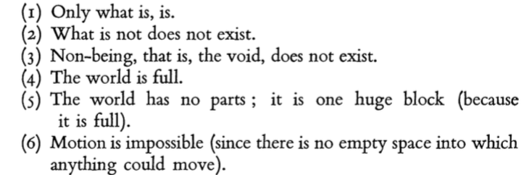

Given 5 and 6 are contradicted by facts – motion is possible and the world does have parts, we then refute the remainder of the argument.

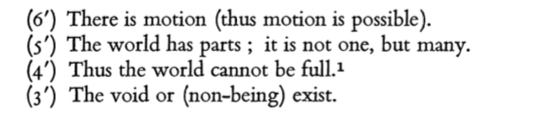

Democritus took on board the idea of indivisibility – but he applied it to atoms. They were objects that were full and had no void inside. The point of this is that it now permitted a rational understanding of change. The world is a void with atoms moving within it. All change is the rearrangement of atoms and thus change is about movement in the void. Since the only kind of novelty that is possible is that of rearrangement then it would be possible in principle to predict future states provided we manage to predict the motion of point masses.

Page 20
So now Democritus had a theory of change – a theory which set the scene for later developments in the physical sciences. Popper remarks that Democritus theory of change was embraced by Plato but not by Aristotle. Aristotle developed essentialism: that substances had an essence that was unchanging and a potential which did. Aristotle’s theory failed to influence physics. But Democritus idea that “all change is movement” had a massive influence – all the way through to today (with one important exception: David Deutsch’s constructor theory where change is most fundamentally about possible versus impossible transformations of which movement is an emergent case). Popper does observe that some change – like the forces of Newton or the fields of Faraday and Maxwell were not necessarily explicitly about movement. Popper writes here that:
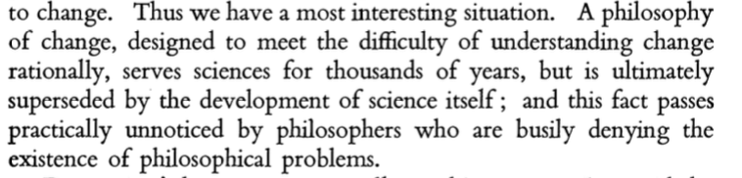
Popper praises Democritus solution to the problem of what causes change as being the framework within which properly scientific problems could be solved and thus we had an understanding of combustion, sound, hardness of materials, state changes in thermal physics and so on.

Page 21
Popper explains how Democritus atomic theory established a philosophical methodological rule: a theory or explanation needed to be in agreement with experience. This is key. It’s not quite falsificationism – it is prior even to that. Unlike with Aristotle who seemed to reject experiment in favor of so-called pure reason – Democritus’ physics proceeded on the assumption that explanations must be connected to our experiences or observations of the world.

Also Popper observes here that speculative theories about the invisible world (Democritus’ atoms) could be accepted or rejected based on observations of the visible world. And here we have the beginnings of the insightful way David Deutsch puts this issue, that often – very often – science is about explaining the seen in terms of the unseen. This philosophy – say Popper – the philosophy of being able to observe the seen as a check on theories about the unseen, is a solution that defends science against relativistic and positivistic tendencies. Let’s just recall that a relativistic tendency is that which inclines one to reject truth, or observation or reality and the positivistic tendency is that which inclines one to endorse the reality of only what can be observed or which comes to us via our senses and nothing else (so to postulate the unseen would be anti-positivistic).

Popper then introduces what he calls “the most fascinating element in Democritus doctrine” – that of the quantization of space and time. Is there a shortest distance? Is there a shortest interval of time?

Page 22
The motivation for Democritus assuming there was a smallest possible time and space was a response to the paradoxes or problems of Zeno. How can I pick up my tea cup if there is a literally infinite number of points between my hand and the tea cup and to move from one point to the next takes some amount of time? Won’t that sum to infinite time? Popper introduces the story of the discovery of the irrationality of root 2. This is relevant says Popper because it dealt a fatal blow to atomism (as applied to space)

Page 23
This is my explanation of the significance of the irrationality of root 2. The existence of root 2 means some lengths cannot be written down as fractions or integers – in particular they cannot be written down as multiples of the shortest possible length. This idea that measurement must be about counting points simply cannot be possible if it can be shown that some lengths are irrational…no finite number of dots can represent the length. But this was the prevailing view up until that moment. If there is a smallest possible length then any length must consist of a finite number of atomic distances. But if the distance is root 2, or any irrational number – we cannot possibly have a sequence of dots that sums precisely to root 2. For example if we made a square with side length of the smallest possible length (1 atomic distance, so to speak) then the diagonal of that square could not be measured in atomic lengths. It would be exactly root 2 atomic units. An amount that could not be represented by dots. It would be 1 smallest possible length PLUS a little less than half a smallest possible length. This is a strict contradiction! (How can one have half a smallest possible length – that would be smaller than the smallest possible length).

Popper explains that Plato noticed this fact and it is Popper’s belief that Plato’s theory of forms was strongly influenced by it. Plato did not agree with Democritus but he had some sympathy and his academy did teach the theory of Democritus.

Popper writes that Plato realized that the purely arithmetical view of reality – that all is number - the Pythagorean vision – could not possibly be true. And this is why Plato built upon that, and took elements of Democritus own theory to develop his own theory of forms. Ultimately this lead to a new mathematical formulation of reality – another Platonist who followed Plato – Euclid.

Page 24
Popper lays out his case clearly:

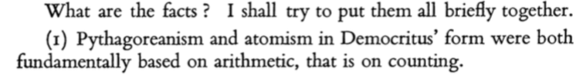

The rest of page 24 cannot really be improved upon by me, and I recommend the original paper to the reader here.

Popper concludes Plato’s theory of forms was not meant to merely be a purely mathematical exercise but rather as a theory of the world. And so it naturally led to the idea that the motion of planets occurred in orbits – perfect shapes. “Ever since Plato and Euclid but not before” writes Popper “it has been taken for granted that geometry (rather than arithmetic) is the fundamental instrument of all physical explanations and descriptions of the theory of matter as well as cosmology.”

Page 25
Popper writes that all of the preceding section amounts to an argument that Plato was solving a philosophical problem about what base reality was like (so a question of ontology or metaphysics). This wasn’t strictly physics or mathematics but it laid the foundation for so much of the physics that came afterwards – from Euclid, Aristarchus, Archimedes, Copernicus, Kepler, Galileo, Descartes, Newton, Maxwell and Einstein. This world view or even approach to epistemology as being informed by geometry – that base reality emerged from perfect forms – was a philosophical world view that helped in the formulation of science that came later and only happened because of the problems Plato was trying to solve with respect to inconsistencies between Democritus atomism (even as applied to space) and the discovery of the irrationality of root 2.
As Popper writes: 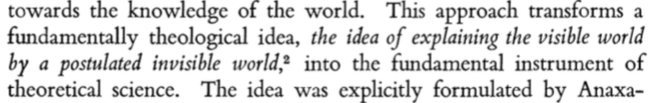
Popper credits Democritus with this notion that visible matter was to be explained by hypotheses about invisibles, about an “invisible structure which is too small to be seen”.
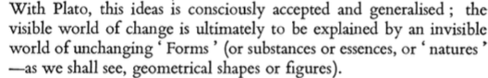

Page 26
Popper then asks of this idea about the invisible structure of matter: is it a physical or a philosophical idea? He says that if a physicist acts on the theory (perhaps without even being conscious of it) accepting the problems of his subject he might produce new theories of matter. In that case he is not a philosopher but a physicist. But if he was to reject that philosophy – that matter has an invisible structure – then what he is doing is plainly philosophy (Berkeley and Mach did this exact thing – Mach rejected atoms until he could see them). Popper then says to worry further about whether we are properly labeling something philosophy or physics is Wittgenstein’s problem – it’s one of linguistic usage and so is indeed a pseudo-problem.

Page 27
He then turns to making some final remarks about Plato’s theory of the structure of matter. In Plato’s view, the smallest solids are crystal like elementary particles and in turn these particles have faces which are simple shapes. Hence we have atoms made of Platonic solids and Platonic solids made of simple shapes. He goes further: the simple shapes – squares or hexagons and so on are themselves ultimately all composed of two elementary triangles – the half square (the isosceles rectangular which has a hypotenuse of root 2) and the half equilateral (which has a root 3 side length). So we incorporate the irrationals into our new platonic atomic theory. The triangles are the copies of unchanging forms or ideas on this view.

Page 28
So it seems clear that atomism can incorporate irrationals and we can once again have a fundamental theory of matter without contradiction. A hole in the theory that Plato seems to have recognized, is that not all shapes can necessarily be made with tessellating those 2 triangles. Indeed Euclid showed that more than just roots 2 and 3 were needed to specify any old length. Lengths were not just multiples of those. Plato seems to hint that he understood this possibility. This in turn seems to have caused Aristotle to realize Plato hadn’t solved the problem he thought he had: he seems to have just introduced Democritus problem of “shortest possible distances” but now it was root 2 and 3 instead. But not everything could be shown to be a multiple of root 2 and 3. So Aristotle seems to have thought Plato’s theory was the same as the Pythagorean theory with a tweak. Ultimately though, Aristotle was not particularly interested in mathematics and did not write much about it.

Page 29
In summary Popper writes tat Plato’s theory of forms was somewhat of a restatement of the theories of Democritus and the Pythagoreans in light of his understanding of the irrationals and this emacipated geometry from arithmetic. By encouraging this emancipation, Plato laid the groundwork for Euclid – the most important deductive system ever constructed (says Popper) and thus we can draw a relatively straight line to Aristarchus, Newton and Einstein all of whom used the toolbox of Euclid.

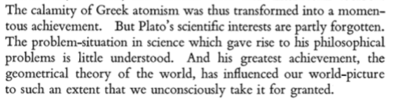
Popper then turns to a second example of a philosophical problem. He says there are many examples but he will use Kant. He says Kant’s Critique of Pure Reason is one of the most difficult books ever written. Popper says Kant wrote too quickly and about an insoluble problem. It’s not a pseudo problem but an inescapable problem which arose out of contemporary concerns in physics. Kant wrote for an audience familiar with Newton and even the history leading to Newton from Copernicus through to Galileo.

Popper writes that it can be hard for us today to appreciate the psychological impact of Newtonian physics upon the early thinkers. Modelled after Euclid, the gravitational force of attraction was felt to bordering on the occult. It had no explanation, after all, though one was initially demanded. Eventually though the success of Newton’s theory was indeed sufficient because of its power to predict near to perfectly where all other contenders had failed. Popper tries to give a sense of what it must have been like for those early thinkers to have it dawn upon them that Newton’s theory is actually true. It was a “unique event” says Popper – one that could never be repeated: the first and final discovery of the absolute truth about the universe. Mankind had obtained knowledge – real and certain – divine episteme or scientia and not merely doxa (mere opinion).
So for Kant, Newton’s theory was simply true and remained this way for 50 years after Kant’s death. But Kant himself although he at first embraced this notion of certain truth, became unsettled about it upon encountering Hume.

Page 30
Hume taught that there could be no certain knowledge. What we knew was obtained with the help of observations of particulars, so our knowledge must be uncertain.
So Kant had a contradiction of sorts. On the one hand: Hume’s contention that repeated observations do not guarantee knowledge or certain truth and on the other the perfection of Newton’s theory.

Kant asked the question, essentially of Newton’s theory: here is knowledge. Newton’s theory is knowledge. But how is it obtained? The question was inescapable but also insoluble. Insoluble because the idea that Newton’s theory constituted episteme – that is to say certain knowledge or incontrovertible knowledge we now know to be false. But Kant didn’t know that. No one did. So it was a real and open question as to how it was possible to ever obtain it given all we had were observations of the real world. There is a philosophical problem if ever there was one: how is knowledge creation possible?

We now know that Newton’s theory is knowledge but not episteme. It is conjectural. Popper solved that for us. Popper says we now know Newton’s hypothesis was just that: an astonishingly good approximation: unique for sure, but not divine and perfect. It is doxa in the final analysis, not episteme.

Popper writes that Kant’s own solution to his problem was “a strange mix of absurdity and truth”. He tried to say that our minds impose physical laws onto reality. We produce the laws in the same way we digest food: it is natural for us to somehow find these laws in our mind and then impose them upon nature. Our senses gather data, these in our mind form themselves into mathematical relationships and then this is imposed upon nature.

Page 31
Kant is suggesting that natural science is not merely possible, it is necessary given our mental make up. It then becomes amazing to Kant why it took so long for Newton to make his discovery and it is a mystery why everyone else didn’t. Everyone else has a digestive system converting food to waste, so why aren’t the rest of us converting perceptions into mathematical laws?

Popper says we cannot dismiss this so easily, even though it might be absurd. It is no pseudo-problem, the question of how knowledge is possible. Popper frames this as the question “How are successful hypotheses possible?” Popper gives his own Popperian answer, so I will reproduce it here, in full. He writes:
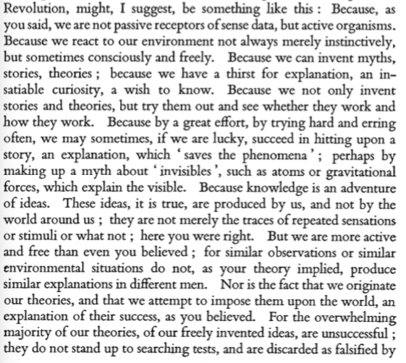
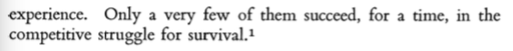

Page 33
Popper says that people today seem to have forgotten Kant’s problem situation. What he was trying to solve –a deep question about epistemology that Popper himself made progress upon.

So in all these cases, this “philosophizing” that went on was not simply science or mathematics – it was motivated by particular problems in those areas, but it was not identical to those areas. It was deeper to, and prior in a sense, to purely scientific or mathematical questions. Can matter be reduced to nothing but indivisible points or atoms? Does this mean lengths too must be quantized? But then what place for irrational lengths?

Popper says that many philosophers inherited Kant’s terrible style of writing but have failed to try and understand his problem situation. They are simply riffing on Kant or the work of other philosophers rather than looking at problems outside philosophy that have philosophical content. Popper writes in conclusion that:
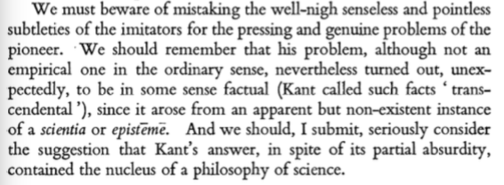

So that’s quite amazing. Popper gives Kant his due there. He was striving to understand how knowledge was possible because he thought Newton’s theory of gravity was certain truth but he also understood that the means by which we seem to come to understand the world was through observation and yet, as Hume observed this could not possibly generate certain truth.

Popper is saying Kant was dealing with a genuine problem. A problem, I’d submit, Popper solved in large part (knowledge is generated iterative cycles of conjecture and refutation and remains conjectural and an approximation to reality). But Popper says Kant’s uneasy style of writing has been emulated by other philosophers. In mind I can only guess he means Wittgenstein.

Now the context for this story, as I have said, can be found in Wittgenstein’s Poker by Edmonds and Eidinow. And the scientific and philosophical consequences can be found in Chapter 12 of “The Beginning of infinity” where David writes about the effect bad philosophy has had on science, in particular on quantum theory. So that’s another genuine philosophical problem. Is instrumentalism valid? What, if any, is the advantage of being a realist for a scientist wanting to make progress?

